

**ITE1014- HUMAN COMPUTER INTERACTION**

**DIGITAL ASSIGNMENT-1**

**SLOT-G1+TG1**

**DATE-15 MAY 2021**

### Submitted By:

### Bhaumik Tandan

### 19BIT0292

### **PRESENTED TO :**

**PROF.RAJESWARI C.**

### **TITLE:**

### **ALARM APPLICATION IN SMART WATCH – BAD UI/UX**

**1. 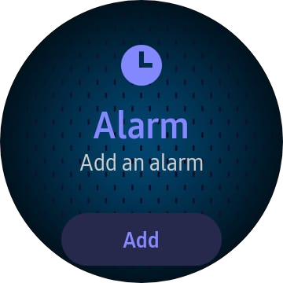Experience**

Before the lock down period, I used to go out for exercise everyday, and I decided to schedule a repeating alarm in smart watch as it is easier to access and I always wear it even while sleeping. So I opened my alarm application as you see in the figure, it asked me to add an alarm.

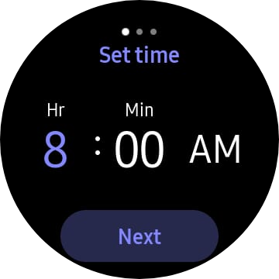

Then I clicked on add and scheduled an alarm for 8 o’ clock. After that **I scrolled right and it asked to turn repetition days**. It looked something like the figure below on the right.

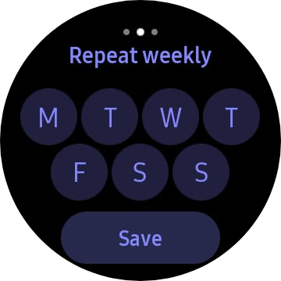

So clicked on all the days (except Sunday) for repetition and slept, it looked something like this. On the next day, the **alarm was not played** and I was not able to go out for exercise. When I woke up I tried to figure out why the alarm was not played. Actually due to the confusion I scheduled the alarm only for Sunday, whereas turned it off for the other days.

**2. Reason Behind my mistake:**

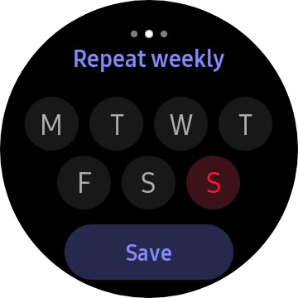

When I woke up I tried to figure out why the alarm was not played. then I discovered that the **purple color means that alarm is on** for that day and black color means that it is off, and for Sunday red means off while purple means on.

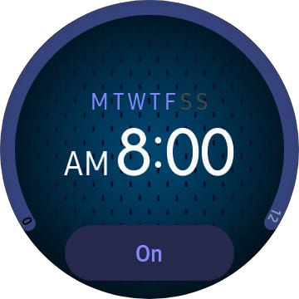

I discovered this by clicking on purple button and making Saturday and Sunday black and red respectively and after that going on the home screen of the application and it showed blur for both the days while clearly means that alarm is off.

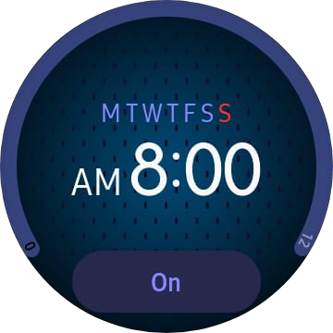

While when I turned both of them on I discovered another issue that I would have faced. **On the repetition window red on Sunday means that the alarm is off**, whereas on the home screen red means the alarm is on. The user can get misguided by this.

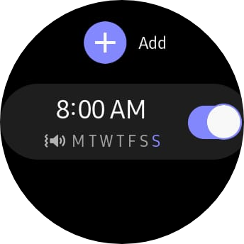

After **clicking on the save button** on the repetition screen, it gets redirected to the page on the right, and here also it is not clearly evident about the repetition. In the screen it signifies that the alarm is off for all the days except Sunday. Unlike the home here purple is used to signifies that the repetition is on.

**3. Learning:**

After clicking on the save button the user must be clearly shown that the alarm is turned on for which days. It can be done by redirecting the user on the home screen and using the color combination simple and same everywhere. When we **click on a button we are performing an affirmative action** so since by default the user assumes that when he is clicking on the button he is turning on the repetition for that day. So it would have been better if by default repetition is turned off for all days.

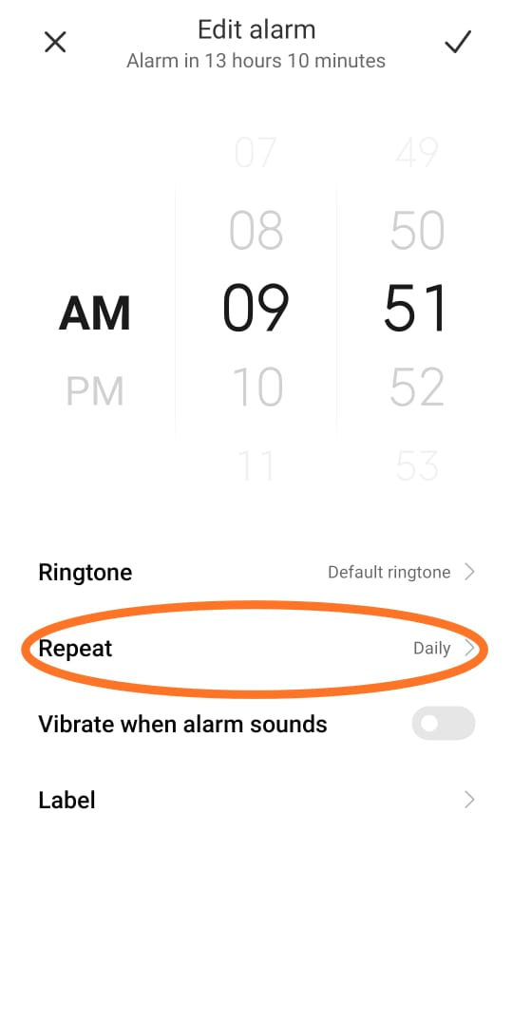**4. Suggestions:**

* The color of all the states should be same in all the screens.
* As shown in the figure on the right There should be a toggle button or menu to make the repetition of the alarm possible, and then only the list of all the days should be displayed, in it we an also include some generally used repetition as shown in the figure bellow.

